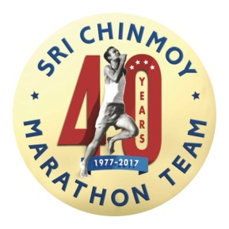 POST RACE REPORT FOR 2017 Sri Chinmoy 7 & 13 Hour Races
Here’s what’s New & Transcended:

~Park gate opens 1.5 hours late. Sri Chinmoy Marathon Team setup team learns that one table, tail gate registration, two cones for start line is all it takes to get the race underway…as long as course is marked the night before!
~Race Director Daulot Fountain amazes the lead runners who he is guiding out on the first loop by crashing his bike on a straight, flat piece of cement road…truly who could do better?! We are off to an exciting day, people!
~First year ever we had to employ a full time “Crow Wrangler” keeping socks, t-shirts, muffins, cookies and chips from being hauled off for crow Saturday morning brunch and nest remodeling. Del loses his cookies.
~PR’s by Matthew Clark (32.34) & new ultra runner and Obstacle Race specialist from Canada, Sara Leblanc (32.34). Others? Cheers to you!
~First place overall female 7 Hour racer was SCMT senior runner Samarpita Broderick (32.34)!
~Del Scharffenberg, told by his doctor to “take it easy Del” for at least 30 days, on his 31st day ran to a FIRST place OVERALL finish in the 13 Hour Race, and his “best race result in 20 years” (58.52)!
~A few runners suffered cramps and minor muscle pulls but stayed in their races till the end.
~The open field 7 Hour Race was very competitive. But in usual distance runner fashion each in his or her own way encouraged their racemates to stay in and push on to do their best. Some stayed in the race to surpass previous mileage goals they had set for themselves. Isn’t that what running is all about?
~The “to die for” post race meal provided by Silence-Heart-Nest Restaurant in Fremont was so well appreciated and not a morsel remained…sorry crows! Special thanks for Sound Sports of Seattle for the great bling draw prizes.
“Self-transcendence joy gives us joy in boundless measure. When we transcend ourselves, we do not compete with others. We do not compete with the rest of the world, but at every moment we compete with ourselves. We compete only with our previous achievements. And each time we surpass our previous achievements, we get joy”
~Sri Chinmoy
The Inner Running and the Outer Running 2008

